Homoscedasticity

What is Hemo?
Homoscedasticity means:
The variance of errors (residuals) is constant across all levels of input variables. Residuals are evenly spread.

Thumb Rule (HEMO)
Residuals look like a horizontal band
Spread does NOT increase or decrease
Variance=constant
Residual plot:
Random, uniform scatter → Homoscedastic

Importance of HEMO
- Assumption of:
  - Linear Regression
  - Logistic Regression
  - ANOVA
- Gives:
  - Reliable coefficients
  - Correct p-values
  - Accurate confidence intervals

Where to Use HEMO?
Area | Reason
Medical data | Reliable prediction
Salary prediction | Fair coefficient interpretation
Economics | Stable variance
Statistical inference | Valid hypothesis testing

Heteroscedasticity

What is Hetro?
Heteroscedasticity means:
The variance of errors changes with input values.Residuals fan out or funnel in.

Thumb Rule (HETRO)
Residuals show cone / funnel / wave shape
Spread increases or decreases
Variance is not constant
Residual plot:
Patterned or widening scatter → Heteroscedastic

Why HETRO is a Problem?

Coefficients may still be unbiased

Standard errors are wrong

p-values become unreliable

Confidence intervals are misleading

Where HETRO Naturally Occurs?
Domain | Reason
Medical costs | Expenses rise with severity
Salary data | Higher salaries have more variation
Finance | Volatility clustering
Housing prices | Expensive houses vary more

Is HETRO Always Bad?
For statistical inference → BAD
For pure prediction → Acceptable
Tree models don’t care about heteroscedasticity.

How to Handle HETRO?
Method | When to Use
Log transformation | Salary, income
Weighted regression | Known variance
Robust standard errors | Statistical models
Tree-based models | Prediction tasks

HEMO vs HETRO (FINAL COMPARISON)
Feature | HEMO | HETRO
Variance | Constant | Changing
Regression assumption | Yes | Violated
Inference accuracy | High | Low
Prediction accuracy | Good | Model-dependent
Preferred | YES | Depends
Heteroscedasticity occurs when error variance changes, affecting standard errors and hypothesis testing.

WHICH IS BETTER?
“Homoscedasticity is preferred. Heteroscedasticity is acceptable for prediction but not for statistical inference.”

Thumb Rule to Remember Forever
If variance is constant → HEMO → GOOD
If variance changes → HETRO → PROBLEM
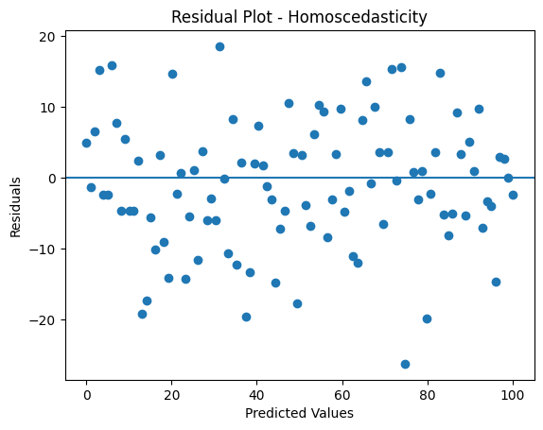

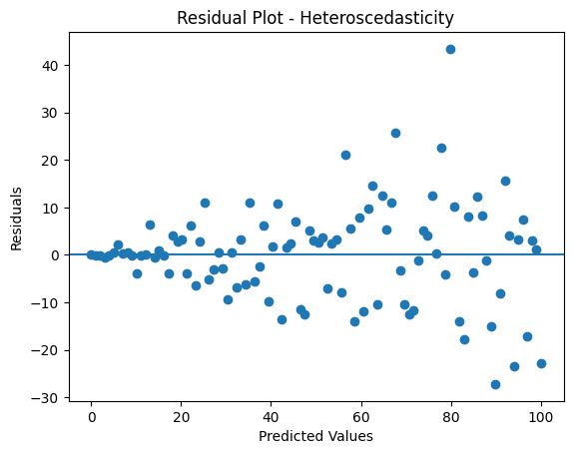

from sklearn.metrics import mean_absolute_error, mean_squared_error
from sklearn.linear_model import LinearRegression
# Train a model (example)
model = LinearRegression()
model.fit(X_train, y_train)
y_pred = model.predict(X_test)
# Calculate errors
mae = mean_absolute_error(y_test, y_pred)
mse = mean_squared_error(y_test, y_pred)
rmse = mean_squared_error(y_test, y_pred, squared=False) # Use squared=False for RMSE
print(f"Mean Absolute Error: {mae}")
print(f"Mean Squared Error: {mse}")
print(f"Root Mean Squared Error: {rmse}")

